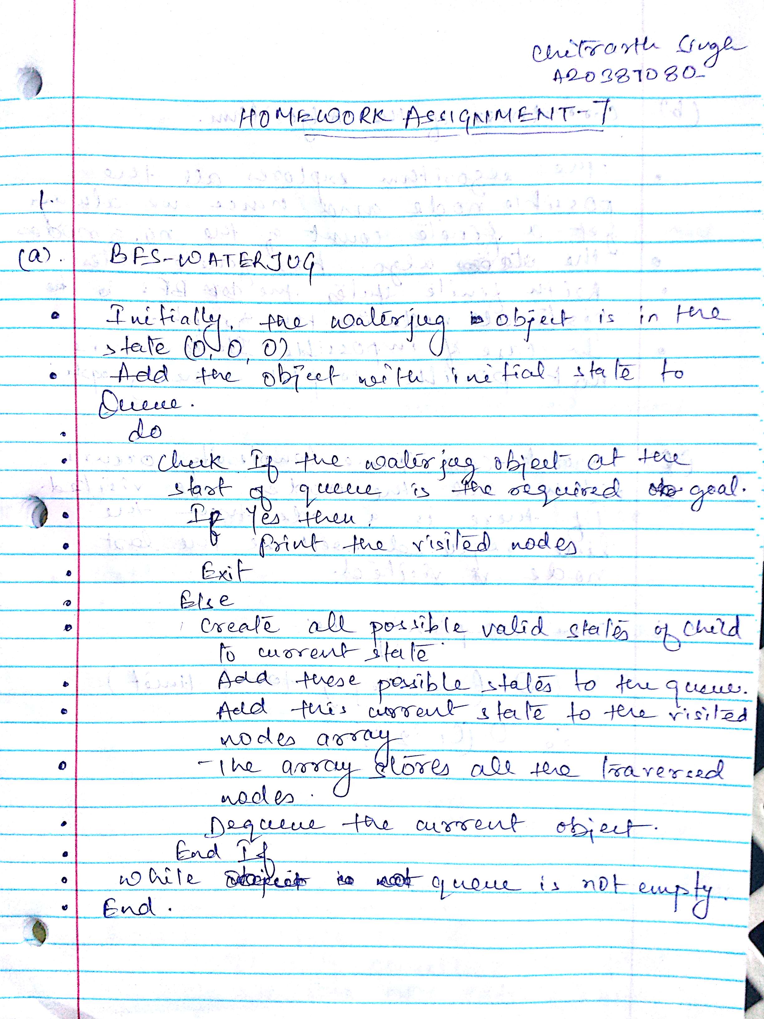

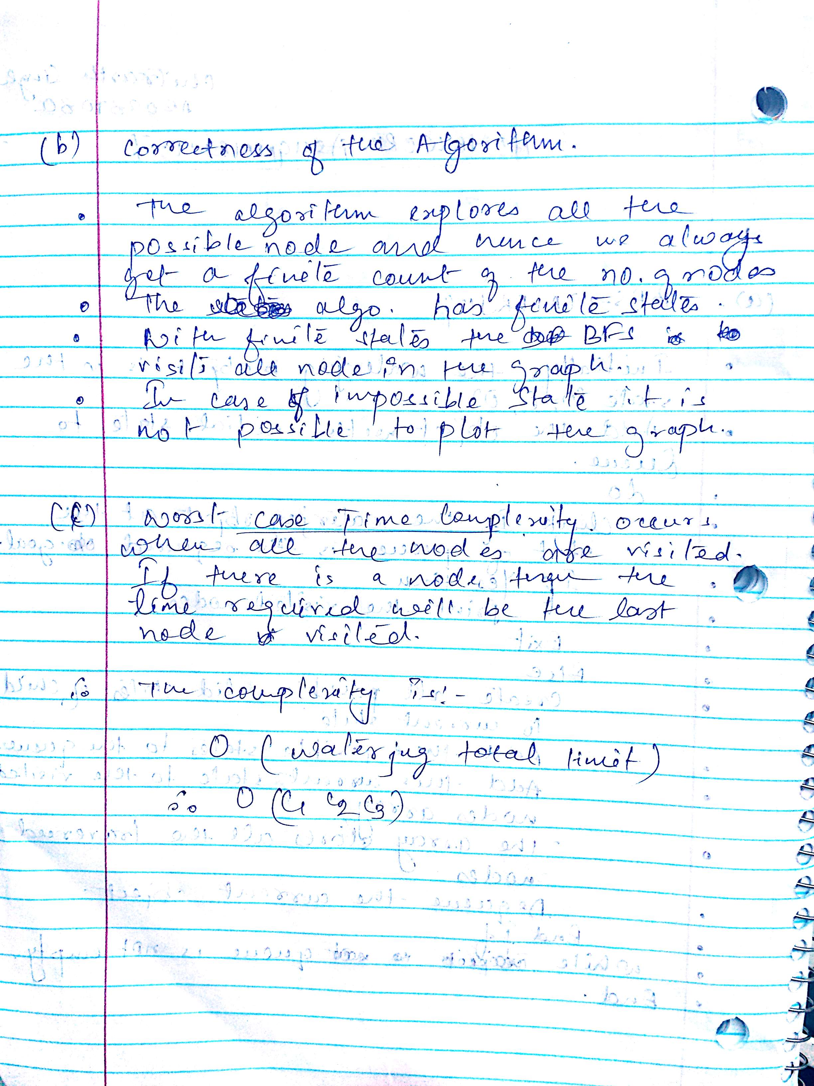

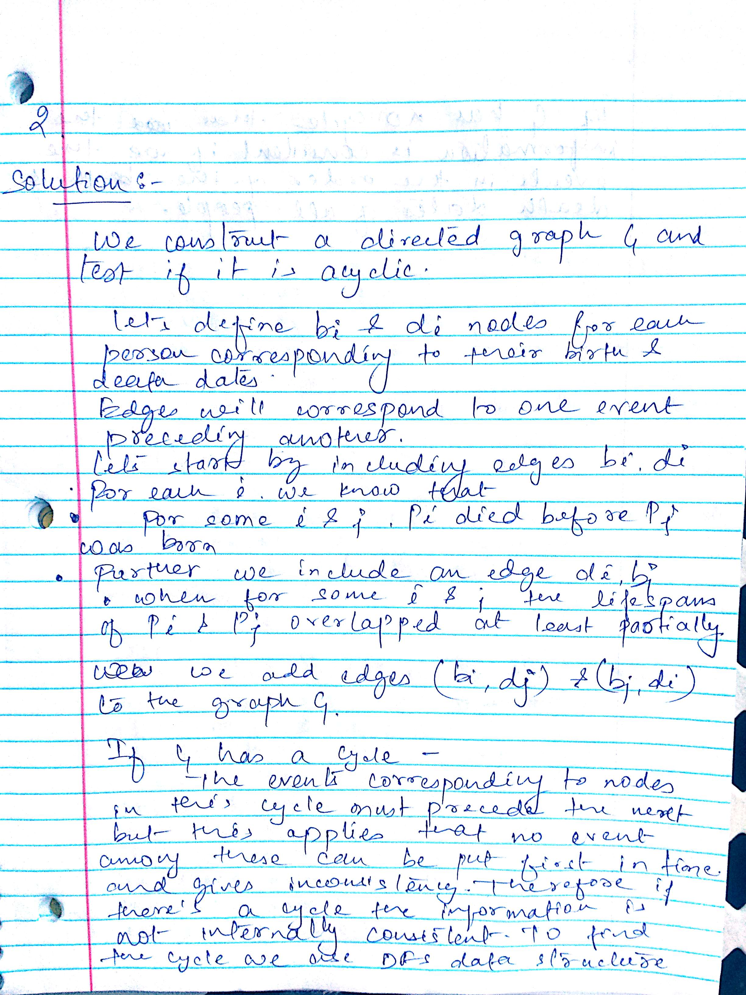

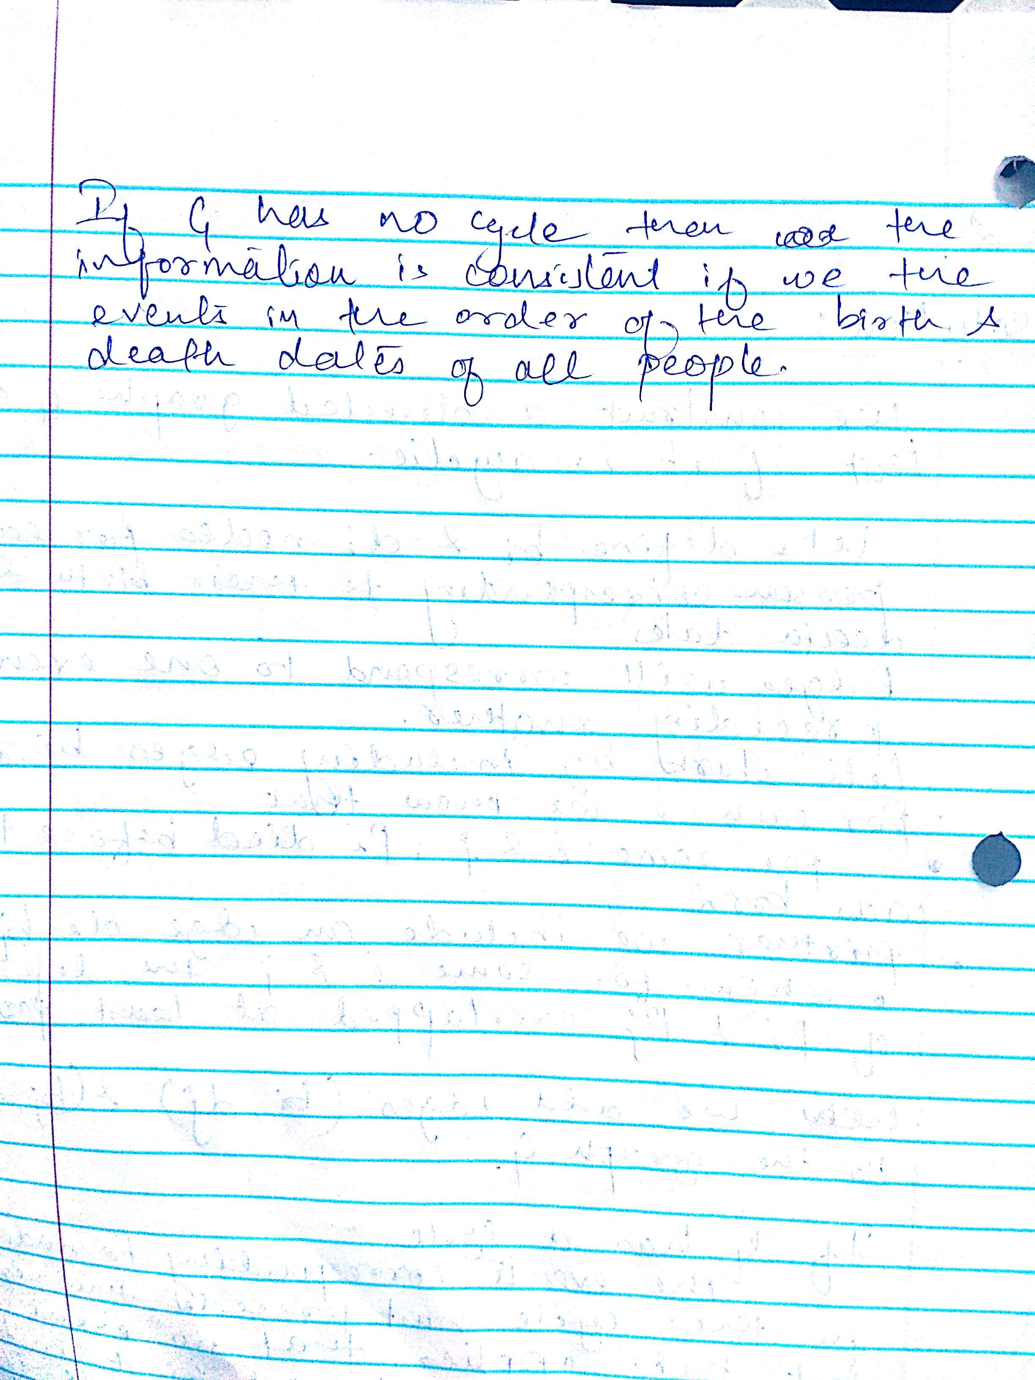

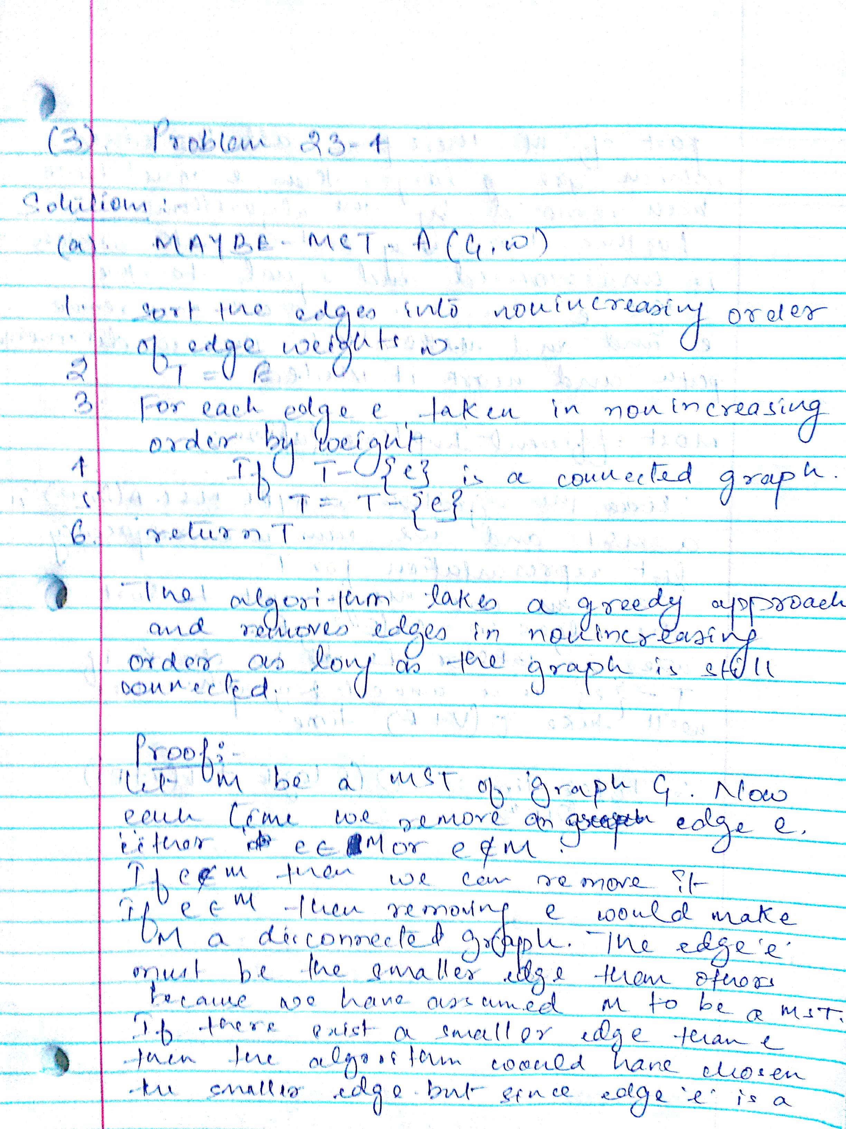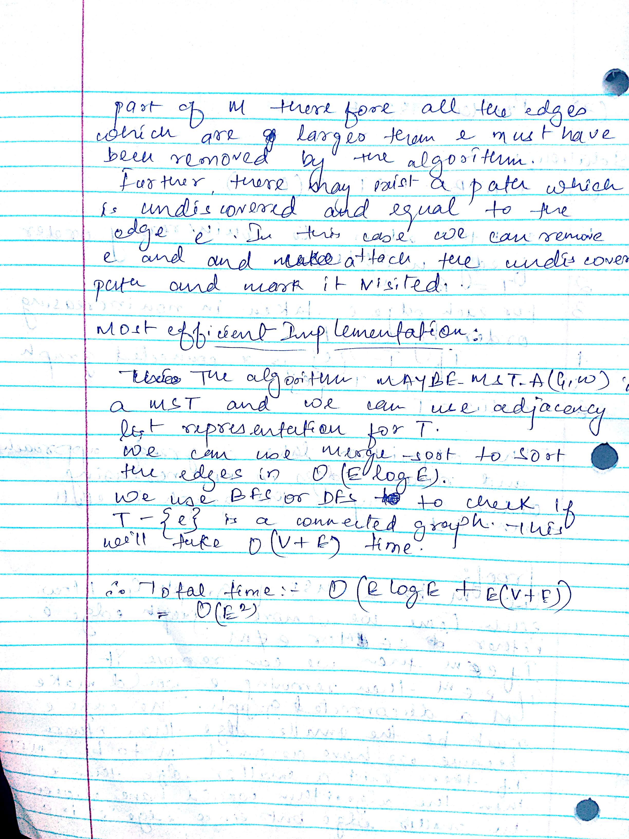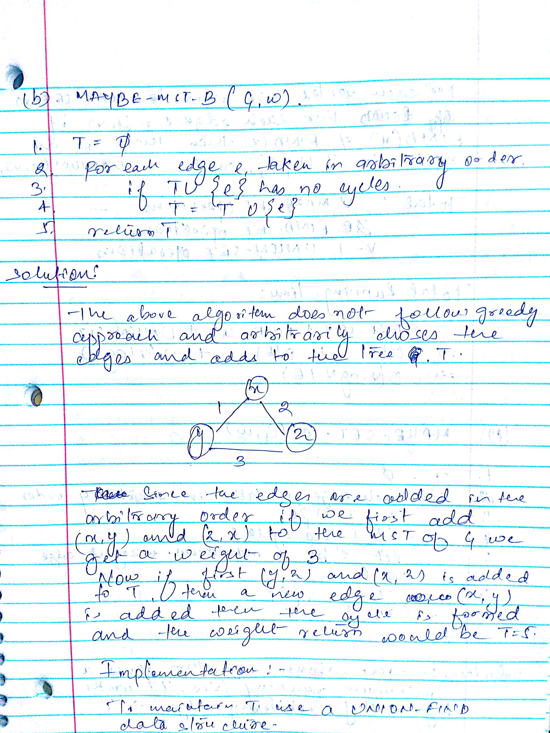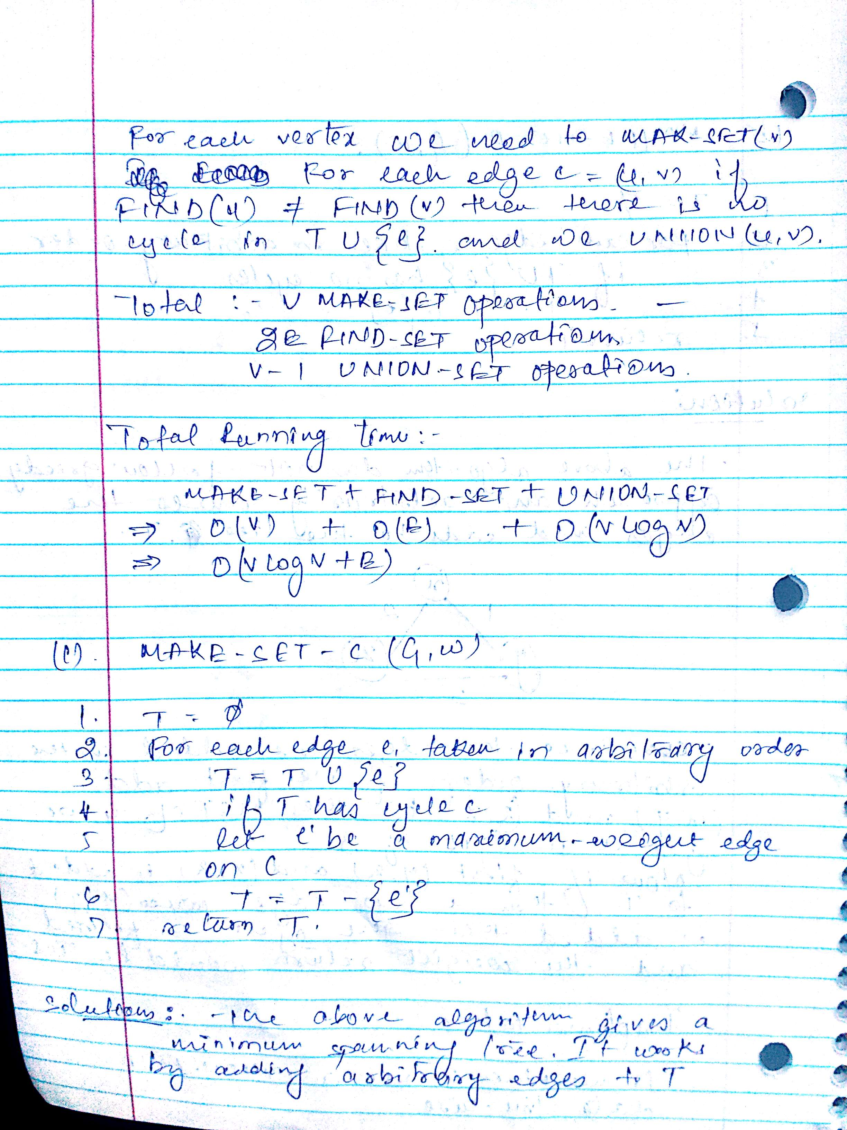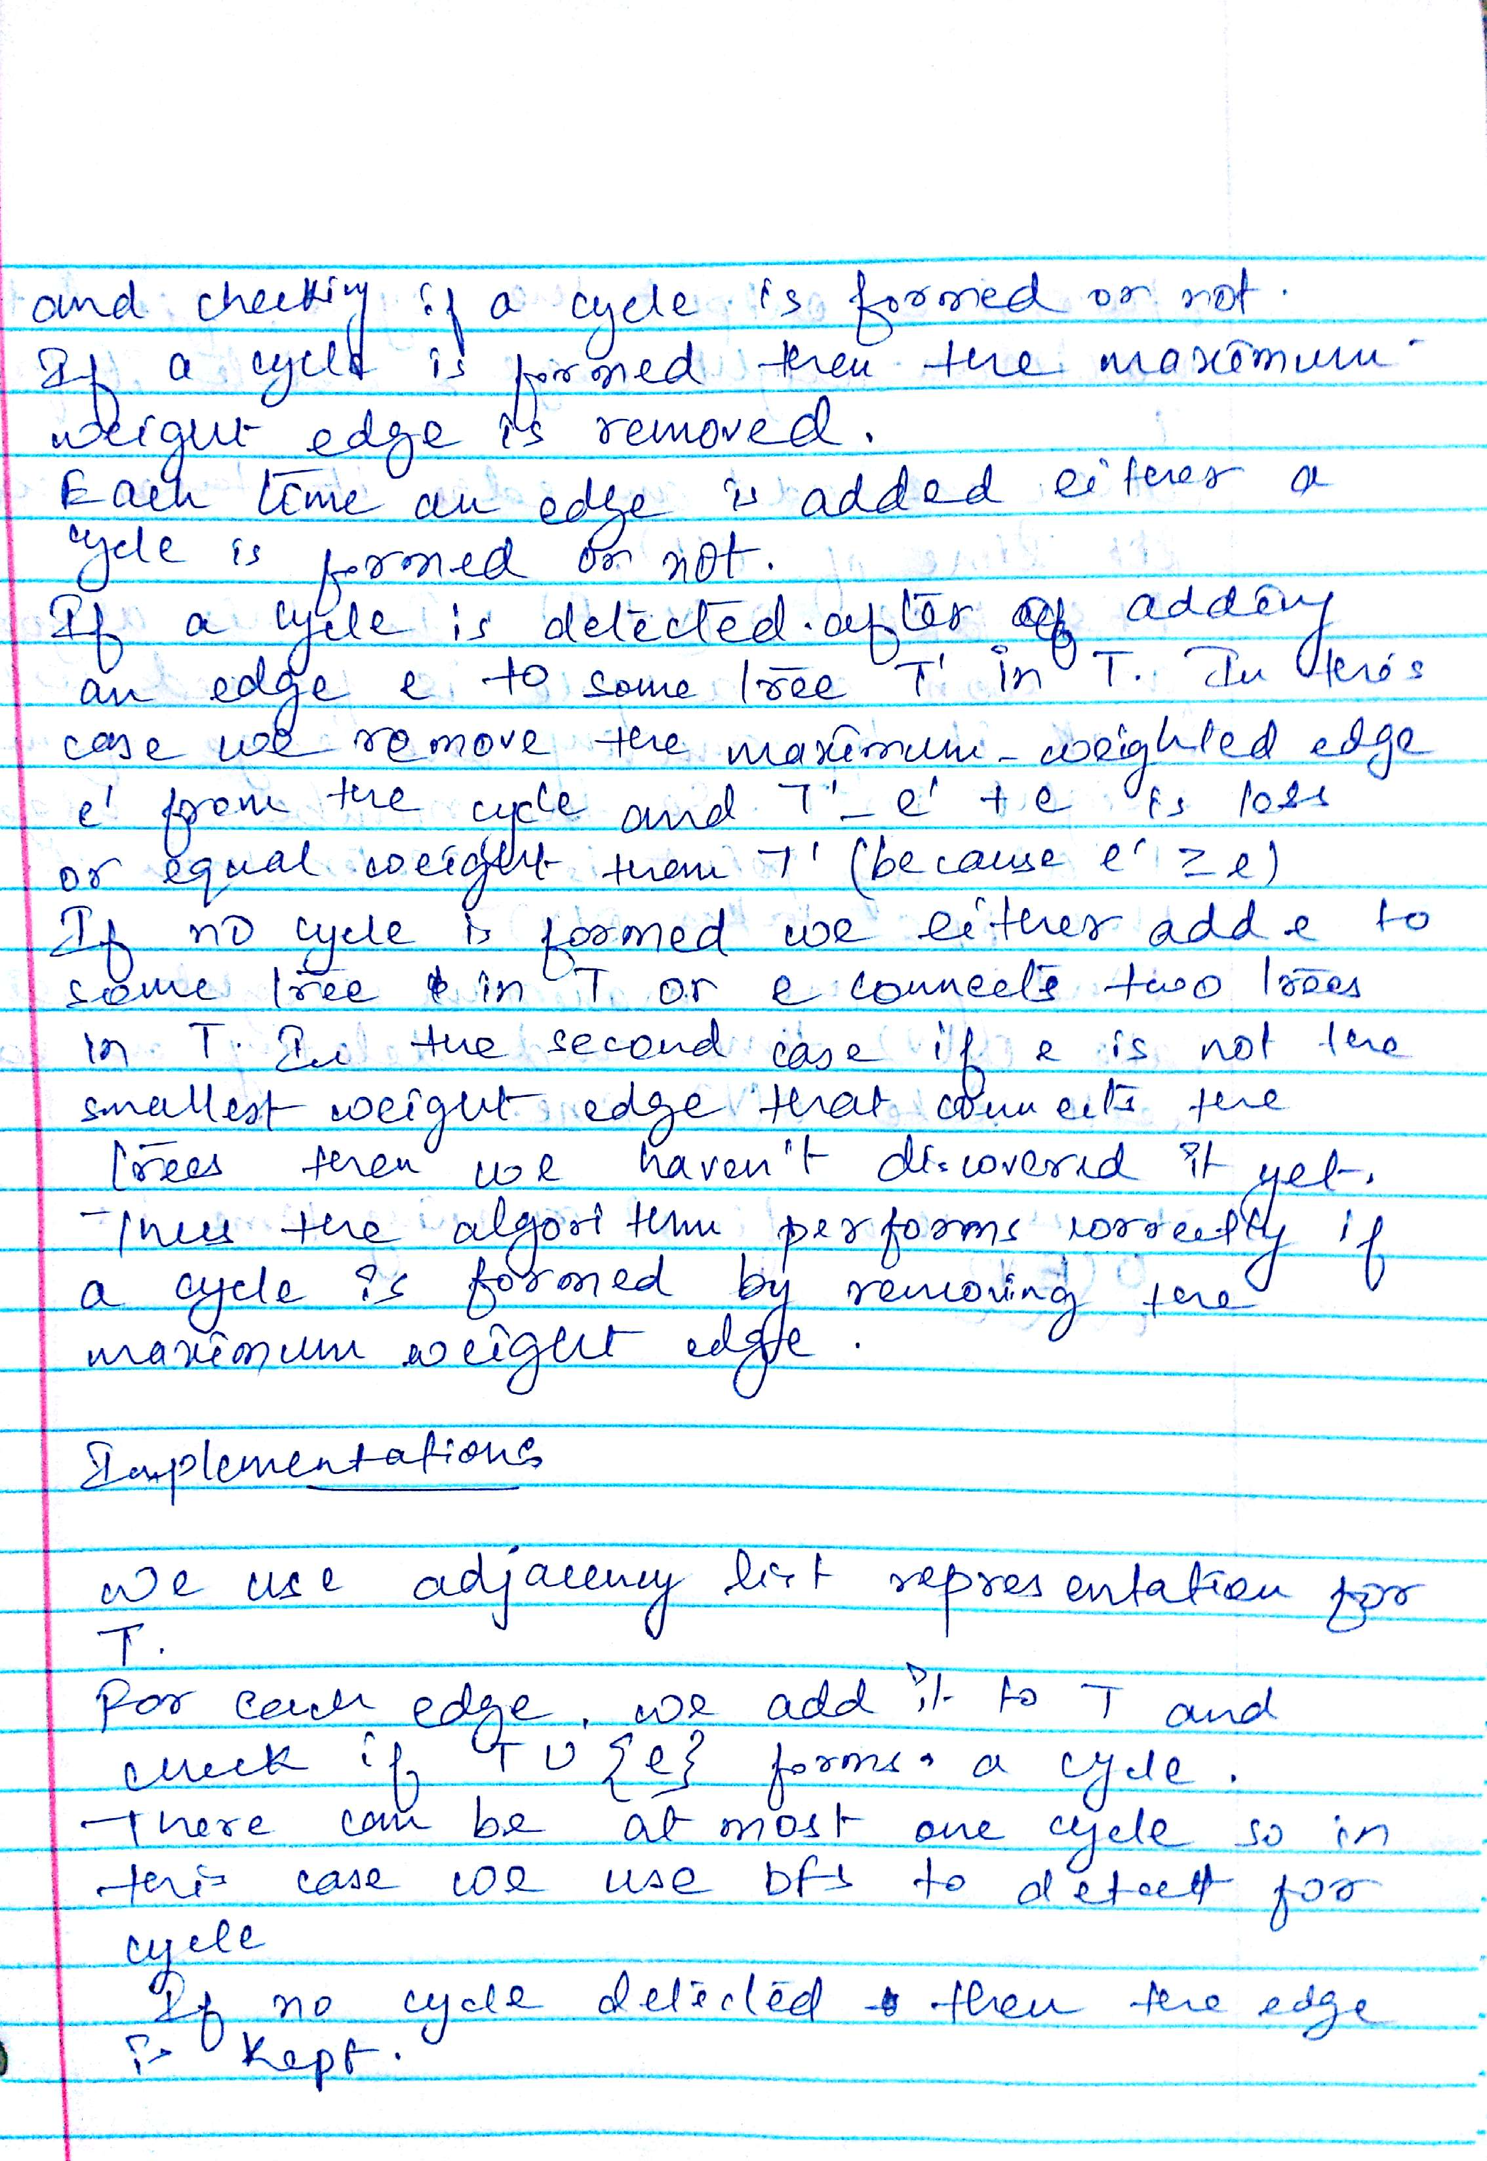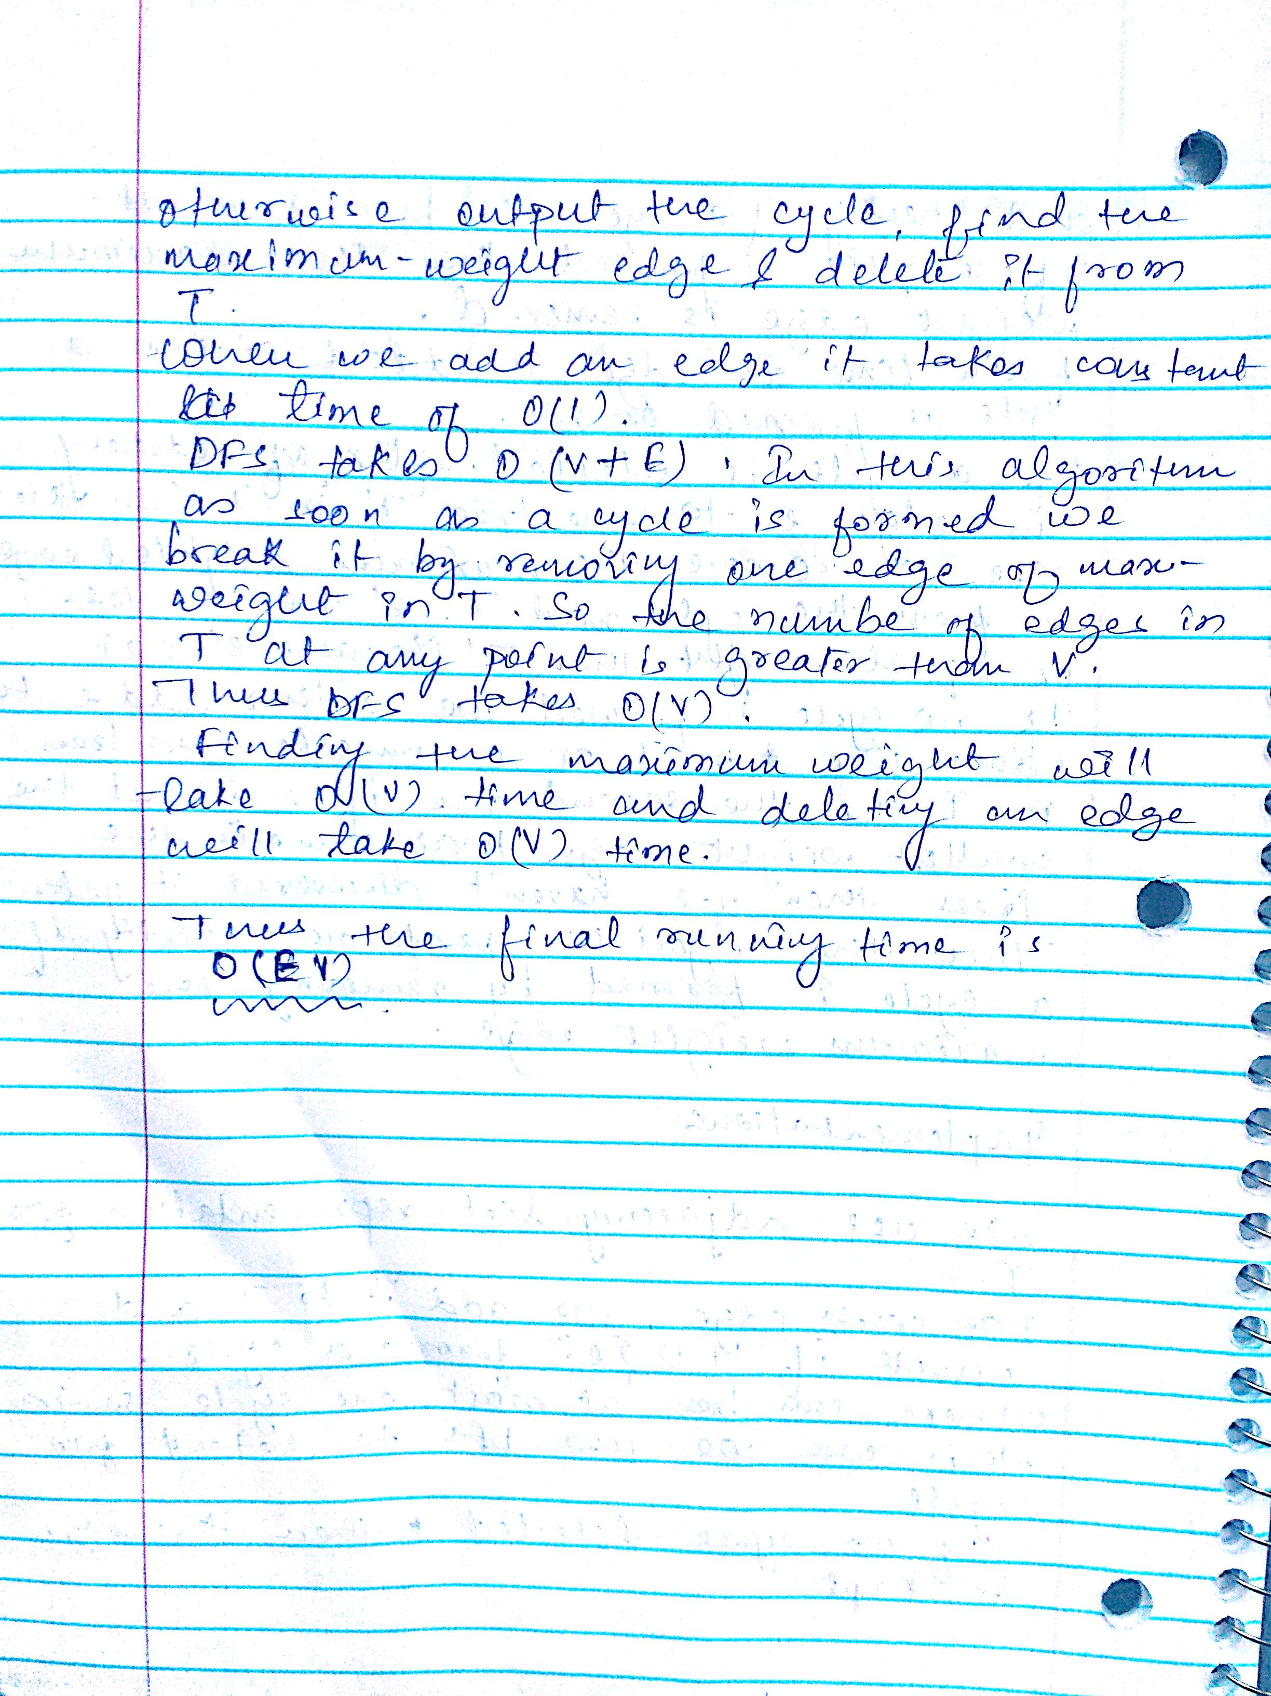

**REFERENCE**

[http://s3.alirezaweb.com/91-5/introduction-to-algorithms/solution-manual/CLRS-Exercises-Introduction-to-Algorithms_Borna66/CLRS-Introduction-to-Algorithms/H20-solution[www.alirezaweb.com].pdf](http://s3.alirezaweb.com/91-5/introduction-to-algorithms/solution-manual/CLRS-Exercises-Introduction-to-Algorithms_Borna66/CLRS-Introduction-to-Algorithms/H20-solution%5bwww.alirezaweb.com%5d.pdf)

<http://homepage.divms.uiowa.edu/~kvaradar/fall2014/hw3.pdf>

**http://projectsgeek.com/2011/09/water-jug-problem-artificial-intelligence.html**